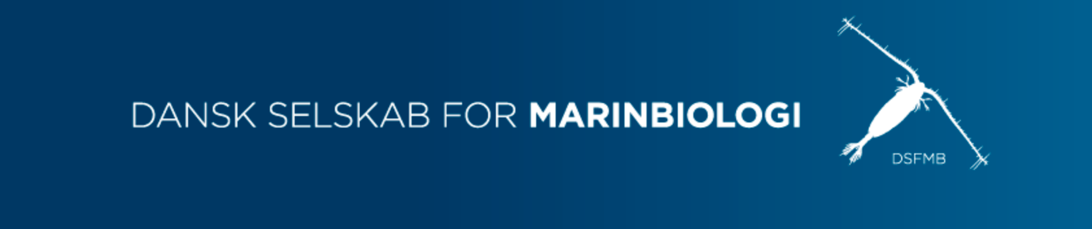

Marine biology in the dark – a deep dive into deep sea research with the global leaders in the field

Location: Universitetsparken 4, 3. sal, 2100 København
Time and date: March 16, 16:30-18:30

With annual general assembly afterwards for those who are interested 18:30-19:30
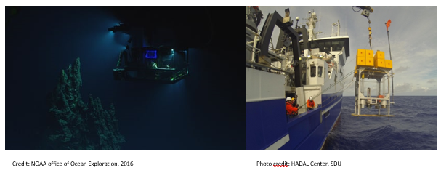
Are you ready to dive deep into the world of marine biology and learn about the creatures and viruses lurking in the abyss? Join us for the first talk of the year in the Danish Society for Marine Biologyr, where we'll explore the mysteries of the deep sea trenches. Our expert speakers, Dr. Sachia Traving and Dr. JP Balmonte, are part of the HADAL Center at the University of Southern Denmark, and they'll be sharing their insights on the fascinating world of microorganisms in these extreme environments.
Despite being 10 km below the sea surface, these hadal environments are home to a surprising amount of biological activity, primarily driven by microorganisms. How do they survive such hostile conditions, without sunlight or access to food sources? And how do scientists access these ecosystems that are so far from the surface of the sea? Dr. Traving and Dr. Balmonte will answer these questions and more, providing a glimpse into the deepest, most remote corners of the ocean.
Don't miss this opportunity to learn from two of the foremost experts in the field of deep sea biology. Join us for an evening of fascinating talks, cold beers, and great company. See you there!
And for those who have an additional interest in the Society, the night will end with the Society’s general assembly where snacks will be served.
Become a member! Only 25,- DKK a year for students.
Go to our website: dsfmb.dk/bliv-medlem

